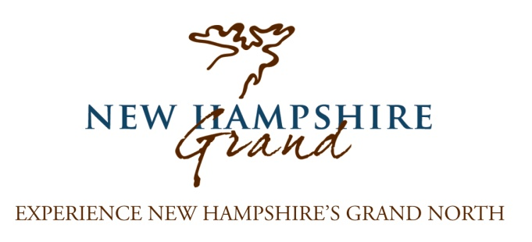
November 10, 2015

Dear Tourism Partner,
It was a fantastic summer and fall with all signs pointing towards a successful stretch for tourism in Coos County! The first eight months of 2015 showed 7% growth in rooms and meals tax within Coos County, continuing our strong upward trend. NH Grand has shared in this success with website visits increasing 35% over the past 12 months, resulting in over 75,000 visits to NH Grand.com!
On the following pages you will find an update on significant new projects underway at NH Grand including an all-new website and map/brochure initiative. These new initiatives complement our established, ongoing efforts. Please take time to read this information; it truly is a very exciting period for tourism in Northern New Hampshire.
I’m contacting you regarding NH Grand cooperative marketing partnerships for 2016. We rely on your support to provide us the income that we use as matching funds to receive grants which market the region and businesses such as yours. Our partnership opportunities are more affordable than most other promotional organizations in the region, and often cost less than a one-time print ad!
Please review these materials immediately. In order for your business to maximize its partnership benefits, we ask that you respond by January 1, 2016. New for this year is a map/brochure promoting our partners - with distribution of 35-50k - that we must print well in advance of the summer season.
We hope based on the enclosed information, that you see the value in partnering with NH Grand and will be inspired to renew or begin your cooperative marketing partnership for 2016. I encourage you to call me if you have any questions or ideas at (603)-788-2700 x2143. Often a phone conversation may help you better understand NH Grand, and how your business can benefit.
Thank you in advance for your partnership!
Sincerely,

Karl Stone
Marketing Manager
NH Grand & NCIC

